**Counseling Services**

Helping You to Reach your Full Potential!

Confidential, free, safe, and nonjudgmental care.

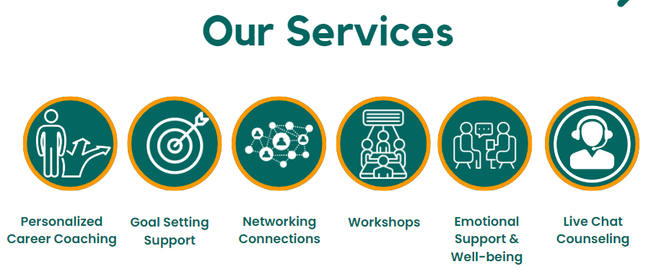

**“Personalized Career & Life Coaching”**

Individual counseling offers the opportunity for students to work through issues that are affecting their functioning with the guidance of a CDCC counselor. All students are welcome to access our coaching through appointments. Appointments enable students to address a specific concern or to determine which other services might best address their issues.

**What**

The University Career Development & Counseling Center (CDCC) provides confidential short-term individual counseling in which a student meets one-on-one with a counselor for one or more individual sessions, usually lasting 45 to 50 minutes. Although the counselors have individual styles, they are all skilled in nonjudgmental, compassionate, and empathic listening. They also strive for multicultural understanding and can help students better recognize their unique experiences and problems from the Christian perspective. Counselors can serve as a sounding-board for problem-solving or can help students develop tools and strategies for coping with a variety of problems.

**Who**

Many students find it helpful to use the CDCC services at least once during their academic experience. We also recognize that seeking counseling is not easy to do and may not be acceptable in some cultures. We encourage you to reach out to the many support services offered by the University, including the CDCC, when you or a friend are struggling. CDCC counselors understand the Asia Pacific International University experience and college student mental health and can help.

If you aren’t sure whether counseling is right for you, consider contacting us through TEAMS or our QR codes to ask any questions. Workshops and Support Spaces are also great opportunities to learn about UCC services without needing to come to the CDCC for individual counseling.

**Where**

In person Drop-In hours are held weekdays at the Career Development & Counseling Center office SA 201B / 201C on the second floor of the SA building next to the football field. Students may make an appointment that works for both the counselor and themselves or visit during the Drop-In hours as follows:

* Mondays: 2 p.m. - 4 p.m.
* Tuesdays: 10 a.m. - 4 p.m.
* Thursdays: 10 a.m. - 4 p.m.

**How**

Simply make an appointment to meet with a counselor or stop by the CDCC during Drop-In hours.

When you arrive for an appointment, you will be asked to complete a questionnaire. This initial questionnaire is a way for us to learn more about you and your concerns, and the information will help guide your appointment.

Appointments are typically 30 – 45 minutes long and are focused on your current situation and what types of changes you would like to see in your life. You may find that talking about things during your appointment meets your needs and that further appointments are not necessary. Or, you and the counselor may decide that some additional services (workshop or on-line self-help tools) can help you explore and address your concerns.

**“Lets Talk”**

**WHAT**

*“Let’s Talk”* is a free and confidential program designed to serve the needs of students through brief, 15 to 20-minute conversations that occur outside the University Counseling Center (CDCC) in easily accessible locations on campus. There are no forms to complete and no appointment to schedule. Just show up and chat!

**WHO**

The “*Let's Talk”* mentors are available to offer support, solutions, and resources for any student with concerns related to stress, sadness, anxiety, difficulty adjusting to college life, academic concerns, family problems, and relationship concerns.

*“Let’s Talk”* is best suited for students who are:

* Unsure about counseling but want to have a someone to offer support to them
* Not interested in ongoing counseling but would like the perspective of a counselor on a specific issue
* Interested in talking to someone about a specific problem
* Concerned about a friend and would like a counselor’s perspective on what to do

**WHERE**

*Let’s Talk* is held as follows throughout the academic year except during University breaks and holidays:

* Thursdays: 2 – 4 p.m.; AIU Library, Room 123

**HOW**

The “*Let’s Talk”* mentors will carefully listen to your concern, ask you some brief questions, and work to understand your goal for coming to “*Let’s Talk”*. Once your problem and goal are clear, depending on your needs, the consultant will offer you suggestions for addressing the concern. You are welcome to return to “*Let’s Talk”* as needed.

Although “*Let’s Talk”* volunteers are great mentors, “*Let’s Talk”* is not a substitute for ongoing counseling. “*Let’s Talk”* is for brief consultation about a specific problem. It is also a place where students are able to have questions answered about counseling services offered at the CDCC.

**Confidentiality**

Conversations with “*Let’s Talk”* mentors are confidential, with a few rare exceptions. Consultants may need to share information in an emergency when there is an immediate threat of harm to yourself or to others. We don’t want anything to be a barrier to students accessing help. If you have questions about confidentiality, we encourage you to discuss them with the “Let’s *Talk”* mentor.

**Meet the Let's Talk Consultants**

**“Let's Talk” Coordinator:**

*Tamara Storie*

**“Workshops & Support Spaces”**

### Facilitated workshops are opportunities for students to identify coping strategies and find new resources to address a specific topic.

### **WHAT**

Workshops are engaging, classroom-like group opportunities where students are introduced to useful information on a particular topic and provided with an opportunity to better understand the topic experientially. Workshops give students a venue to learn and practice new coping strategies or skills. Some workshops are one only session while others involve multiple sessions.

**Spring 2023 Workshops & Support Spaces (see Events calendar for additional information)**

* Time Stops for No Man, Time Management: Workshop
* Anxiety Toolbox: Workshop
* Grief & Loss Support Space
* Feel Better Fast: Help for Depression, Stress & Sleep: Workshop
* GSS Agents - Gods Secret Service Agents - helping ourselves / helping others
* So, you Graduated, What now? Transitioning to the Workplace: Workshop
* Resilience in Diversity: Workshop

**WHO**

All students are welcome to attend.

**WHERE**

Locations vary. Please consult the [Events calendar](https://ucc.nd.edu/news-events/events/) for upcoming workshops.

**HOW**

No pre-registration required. Just show up!

**“Live Chat Counseling”**

Individual Live Chat Counseling offers the opportunity for students to work through issues that are affecting their functioning with the guidance of a CDCC counselor. All students are welcome to access our Live Chat Counseling through appointments. Appointments enable students to address a specific concern or to determine which other services might best address their issues.

**What**

Live Chat Counseling services enable students to meet with a center counselor to address a specific concern or to determine which services might best address their issues.

**Who**

All students are welcome to utilize Live Chat Counseling services as-needed for immediate concerns. However, if you would like to see the same counselor you worked with in the past, please schedule an appointment with that counselor. If you would prefer to work with a different counselor or if you have an immediate need, please contact us through our line QR code.

**Where**

Live Chat Counseling services are available anywhere you have access to the internet and computer, phone, iPad or other device.

**How**

Simply make an appointment to meet with a counselor by teams or via our line QR code.

When you make your appointment for Live Chat Counseling services, you will be asked to complete a questionnaire. This initial questionnaire is a way for us to learn more about you and your concerns, and the information will help guide your appointment.

Appointments are typically 30 – 45 minutes long and are focused on your current situation and what types of changes you would like to see in your life. You may find that talking about things during your appointment meets your needs and that further appointments are not necessary. Or, you and the counselor may decide that some additional services (workshop or on-line self-help tools) can help you explore and address your concerns.

**“Concerned others”**

Career Development & Counseling Center (CDCC) counselors are available to consult with concerned faculty, staff, parents/guardians, and/or students who are seeking guidance about how to handle a mental health concern involving an Asia Pacific International Student. Faculty and staff are often the first to detect and respond to student concerns. Likewise, parents, guardians, family members, or a student’s friends may notice changes in behavior that lead to concerns about a student’s mental health and well-being. The CDCC offers consultation services through Line or TEAMS to assist concerned others in intervening to help a student get the help they may need.

**The CDCC Warm Line** is a non-emergency helpline that provides responsive consultation to faculty and staff in their efforts to help Asia Pacific International students with mental health concerns.

To reach this service, simply call the CDCC at 574-631-7336 and ask for the Warm Line, which will put you in contact with the next available counselor. The Warm Line is available from 9 a.m. to 4 p.m. Monday through Friday when the University is open.

In crisis situations, concerned others can contact the UCC 24 hours a day, 7 days a week at 574-631-7336 and speak with an on-call counselor about an emergency situation. In life-threatening emergencies, please call 911 immediately.

**Red Folder - Resources for Faculty & Staff**

The Student Health and Wellness Unit is pleased to share the Red Folder Initiative, designed to provide resources and information for faculty, staff and administrators as you support students in distress.

The Red Folder shares indicators of students in distress, a response protocol chart to help you when faced with a distressed or distressing student, and tips for preparing to reach out to a student, connecting with the student and making referrals to resources across the university and in the community.

“See Something. Say Something. Do Something” organizes the recommended response to students showing distressed or distressing behavior.

**A digital version of the Red Folder**[**can be found here**](https://supportandcare.nd.edu/assets/500121/red_folder_1.16.pdf).

The Red Folder drew from examples of several other major universities. We hope that this document and initiative will support you as you do the important work of supporting our students.

**If you have any questions about the Red Folder project, please contact the Center for Student Support and Care at (574) 631-7833 or at care@nd.edu.**

**Confidentiality**

Please be aware that for students 18 years and older, the CDCC is prohibited by our ethical standards from disclosing any information about any student, including whether a student has had any contact with the CDCC, without the student’s written permission. Confidentiality is vitally important to a counseling relationship, as it affords the student a sense of safety in talking about whatever they need to talk about without fear that this information will be disclosed to another party.

If you know your student has been seen at the CDCC and you would like to communicate with a counselor, or if you simply want confirmation that your student is being seen at the CDCC, please ask your student to sign a release of information form which will then allow the CDCC to share information with you. Without a signed release form, the CDCC is unable to confirm or deny whether the student is a CDCC client.